**Digital Signal Processing Fundamentals [5ESC0]**

**Lab 5ESC3**

**‘Answer form’**

***Assignment 11 to 17***

**Group number:** 13

**Names with ID:** Martyn van Dijke | 0887668

Marijn Rombouts | 0887946

**Date:** 3 November 2016

**Assignment 11: The DFT of a finite length discrete-time signal**

1. Calculation of X(ejθ)  
     
   Evaluate the signal from n = 0 to n = K – 1 to simplify the calculation (shift by $x\left[n-\frac{K-1}{2}\right]$):

$$X\left(e^{jθ}\right)=\sum_{n=-∞}^{∞}{x\left[n\right]e^{-jnθ}}=\sum_{n=0}^{K-1}{e^{-jθ}}=\frac{1-e^{-jθK}}{1-e^{-jθ}}$$

The geometric series can be expanded to

$$\frac{e^{-j\frac{θ}{2}K}}{e^{-j\frac{θ}{2}}}⋅\frac{e^{j\frac{θ}{2}K}-e^{-j\frac{θ}{2}K}}{e^{j\frac{θ}{2}}-e^{-j\frac{θ}{2}}}=e^{-j\frac{θ}{2}(1-K)}⋅\frac{\sin\left(\frac{θ}{2}K\right)}{\sin\left(\frac{θ}{2}\right)}$$

Which gives the coefficients: $A=1$, $K1=\frac{K}{2}$, $K2=\frac{1}{2}$ and $K3=\frac{1}{2}\left(1-K\right)$

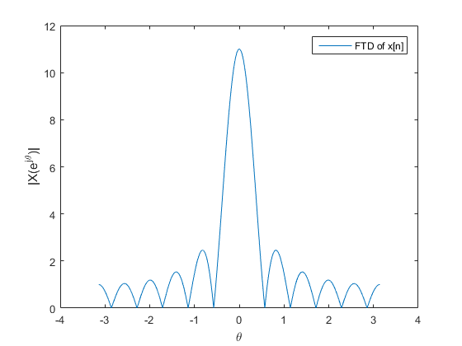

Figure 1: plot for |X(ejθ)|

1. 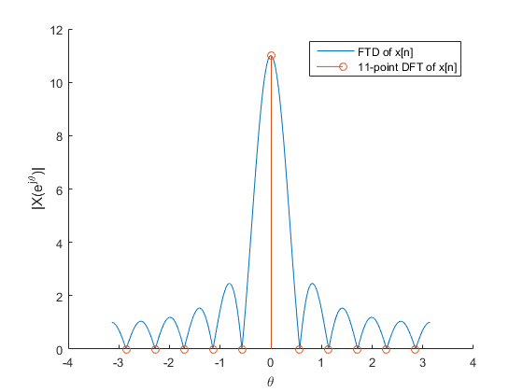

Figure 2: plot for |X[k]|

**Assignment 12: Spectrum of a sine wave of different frequencies**

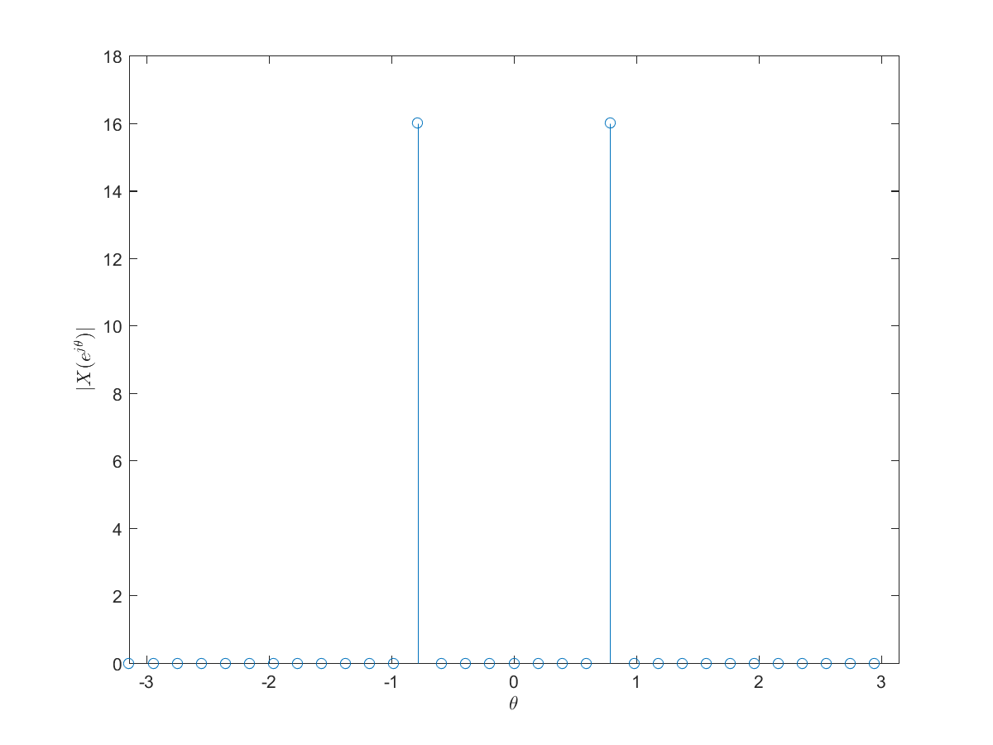

Figure 3: Plot of DFT of x1[n]

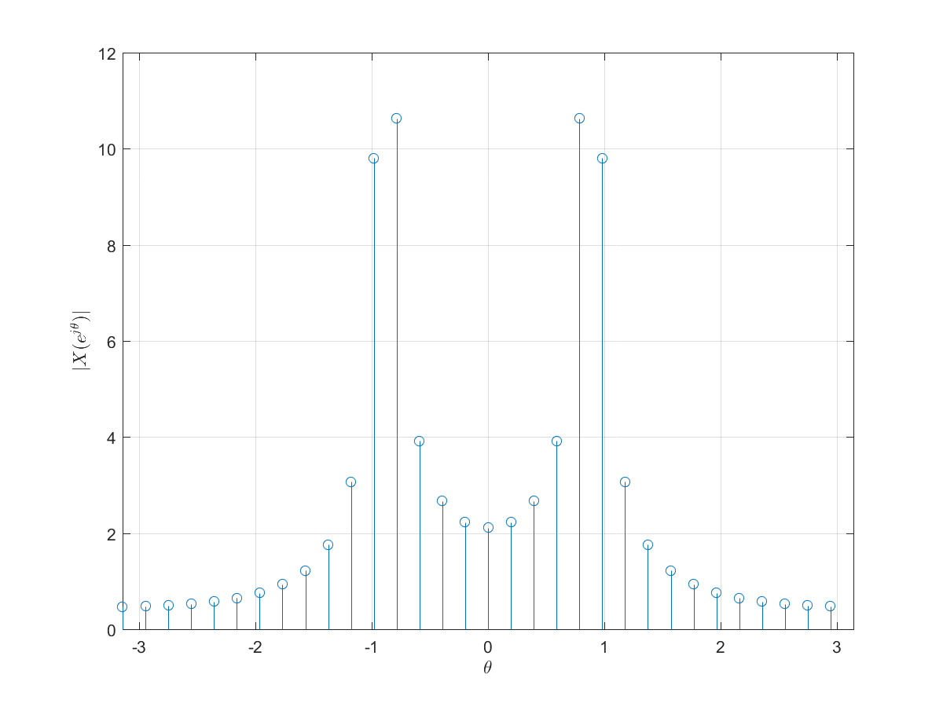

Figure 4: Plot of DFT of x2[n]

1. Explain what you see, why it happens and how to prevent it.

The first signal (Figure 3) is a integer multiple of the sample frequency $f_{S}$ since, $\frac{f_{s}}{f_{1}}= \frac{64}{8}=8$ 
 therefore the signal is always being sampled inside the window function (which is rectangular in this case)   
Since the signal is always sampled inside the window function only the frequency component of $f_{1}$ is plotted which fits exactly in to the window and thus not causing any spectral leakage.   
Since $f_{2}$ is not an integer multiple of $f_{S}$ it is partly being sampled outside the window function, this results in spectral leakage in the DFT plot of $f_{2}$

**Assignment 13: Approximation of the FTD**

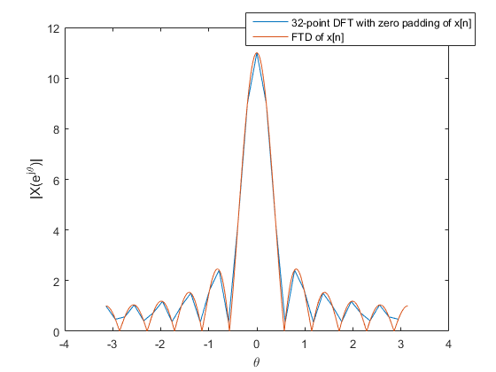

Figure 5: Plot of DFT and approximated FTD

**Assignment 14: Calculating the minimum resolution of a spectrum**

1. Find the minimum length Na:

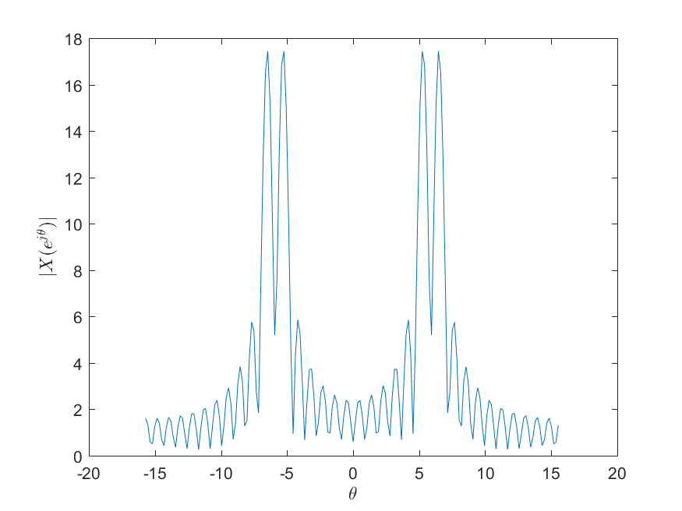

Figure 6: Plot of FTD

1. 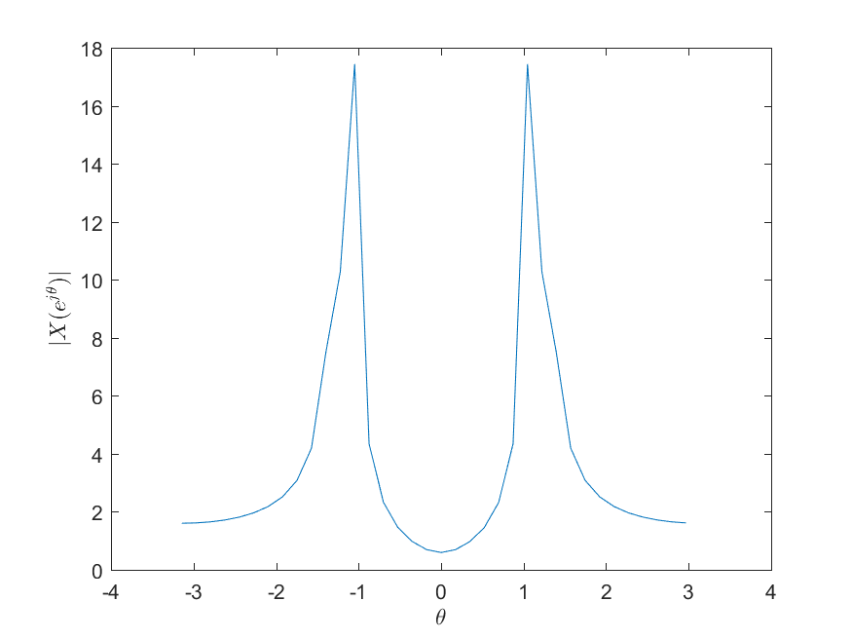

Figure 7: Plot of FTD with new frequencies

Explain the effect of zero padding for this case :

Yes, by adding more zeroes and thus increasing the DFT length, the two peaks of interest do become visible.   
This is due the fact that zero padding does not alter the information of the input signal ($x_{n}[n]$) but increase the “resolution” of the DFT transform.   
In other words, zero padding decreases the distance between DFT samples and thus ensures a smoother data set, and thus having enough DFT samples in order for the peaks of interest to become visible.

1. Nb calculations for the new frequencies

$$∅_{1}=2π*\frac{f_{1}}{f_{s}} , ∅_{2}=2π*\frac{f_{2}}{f_{s}}$$

$$With f_{1}=185Hz , f_{2}=200H_{Z} and f_{s}=1000Hz$$

$$∆∅= ∅_{2}- ∅_{1}= 1.1624- 1.0996= 0.0628$$

$$0.89* \frac{2π}{N}= ∆∅ → \frac{2π}{N}= \frac{∆∅}{0.89} → N= \frac{2π*0.89}{∆∅}$$

$$N_{b}= \left\lceil \frac{2π*0.89}{∆∅}\right\rceil = \left\lceil \frac{ 2π*0.89}{0.0628}\right\rceil = \left\lceil 89,045\right\rceil =90$$

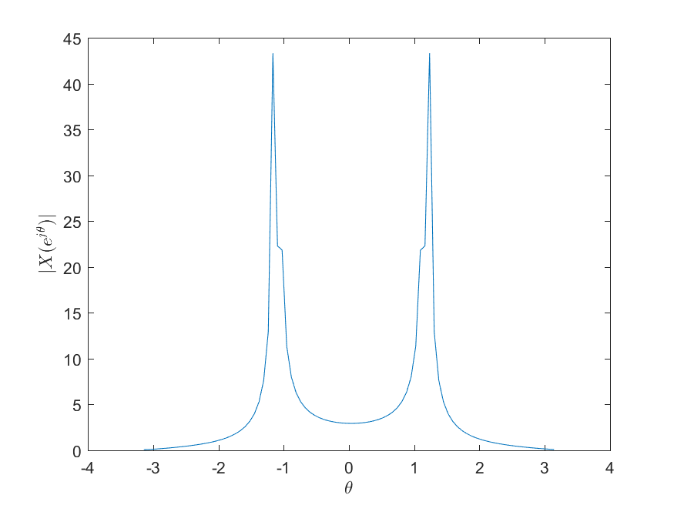

Figure 8: Plot of FTD with the new Nb

1. Calculate Nc for Hanning window

$$∅_{1}=2π*\frac{f_{1}}{f_{s}} , ∅_{2}=2π*\frac{f_{2}}{f_{s}}$$

$$With f_{1}=185Hz , f_{2}=200H_{Z} and f_{s}=1000Hz$$

$$∆∅= ∅_{2}- ∅_{1}= 1.1624- 1.0996= 0.0628$$

$$1.44*\left|\frac{2π}{N}\right|= ∆∅ → \left| \frac{2π}{N}\right|= \frac{∆∅}{1.44} → N= \frac{2π*1.44}{∆∅}$$

$$N_{c}= \left\lceil \frac{2π*1.44}{∆∅}\right\rceil = \left\lceil \frac{ 2π*1.44}{0.0628}\right\rceil = \left\lceil 144,074\right\rceil =145$$

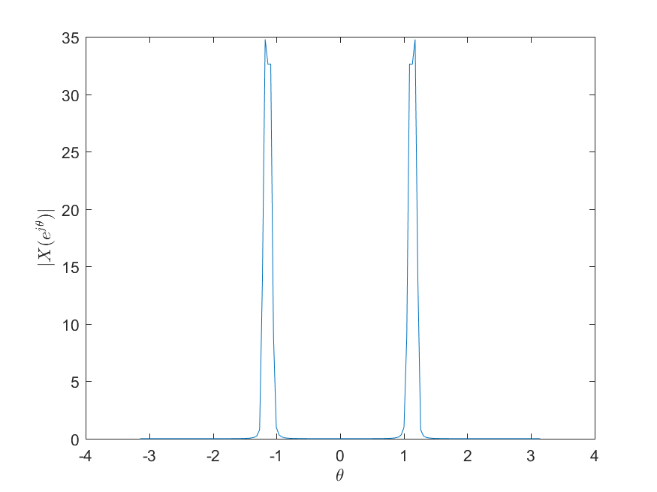

Figure 9: Plot of DFT for Hanning window

Explain about the spectral leakage and amplitudes:

The spectral leakage has been greatly reduced.  
This is due the fact that the Hanning window is a window that is optimized for reducing the spectral leakage, as can be seen in Figure 9, there is almost no spectral leakage outside the area of interest.   
The amplitudes are also lowered this is a side effect of the way the Hanning window is being generated and applied.

1. 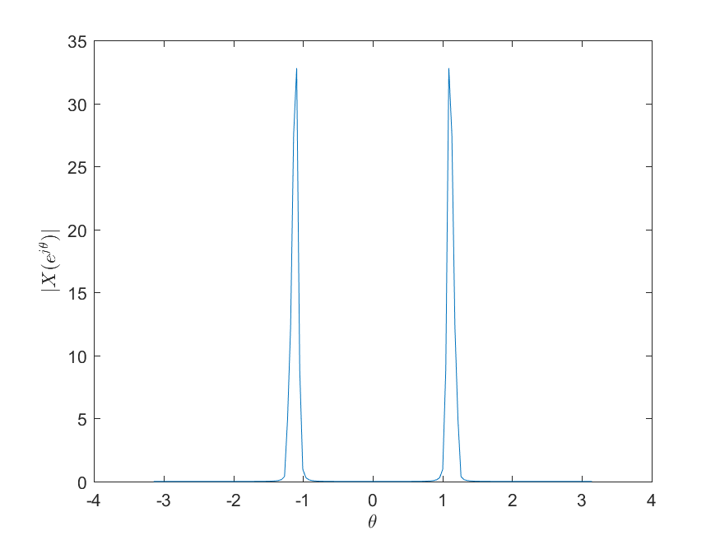

Figure 10: Plot of DFT for the new amplitudes

Explain the phenomena that you see:

No it is hardly possible to detect the two peaks of interest, since the Hanning window is a fast decaying window therefore the second spectral peak is being absorbed into the general first peak and therefore it is not possible to detect the second spectral peak.

**Assignment 15: Linear and circular convolution:**

1. Linear and circular convolution result:

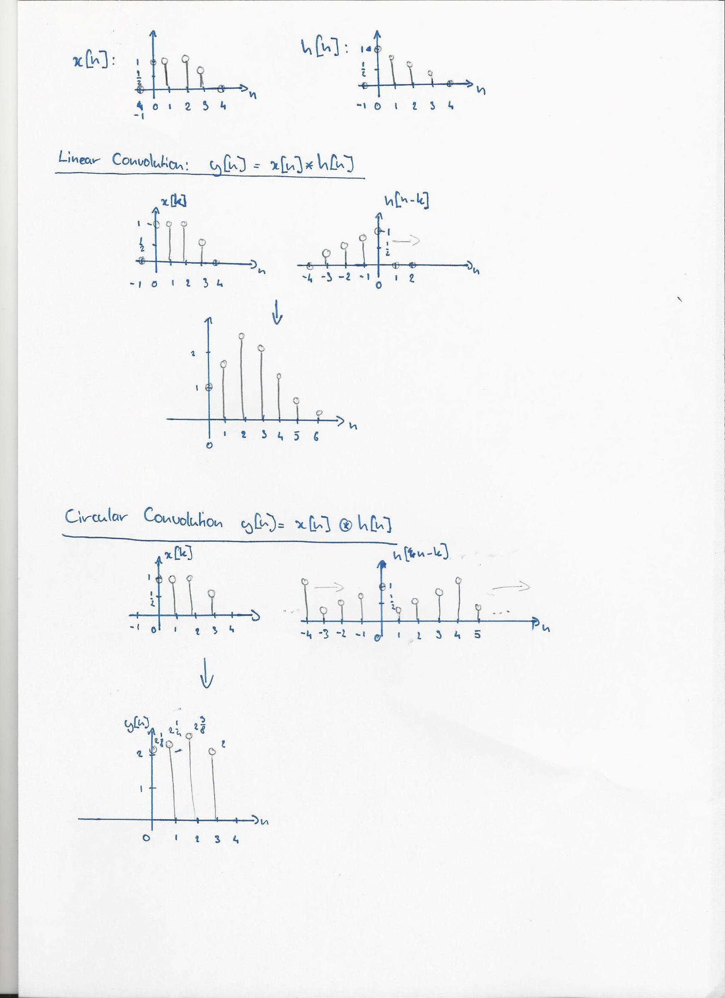

1. Implement and plot circular convolution result:

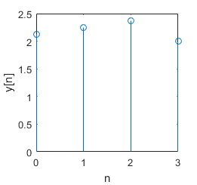

1. Implement and plot linear convolution result:

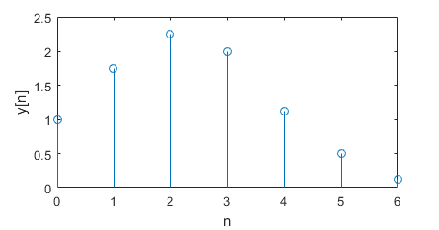

**Assignment 16: Frequency plots of LPF**

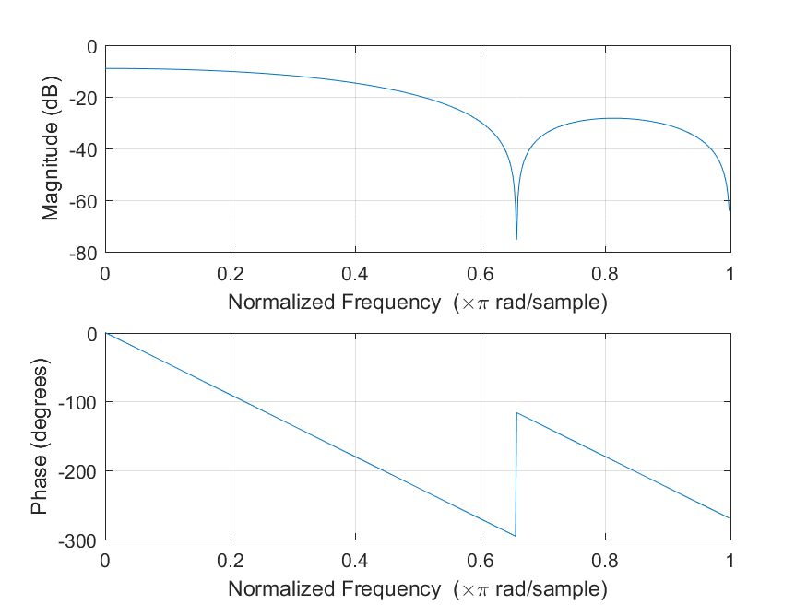

Figure 21: Amplitude and phase plot for N = 5

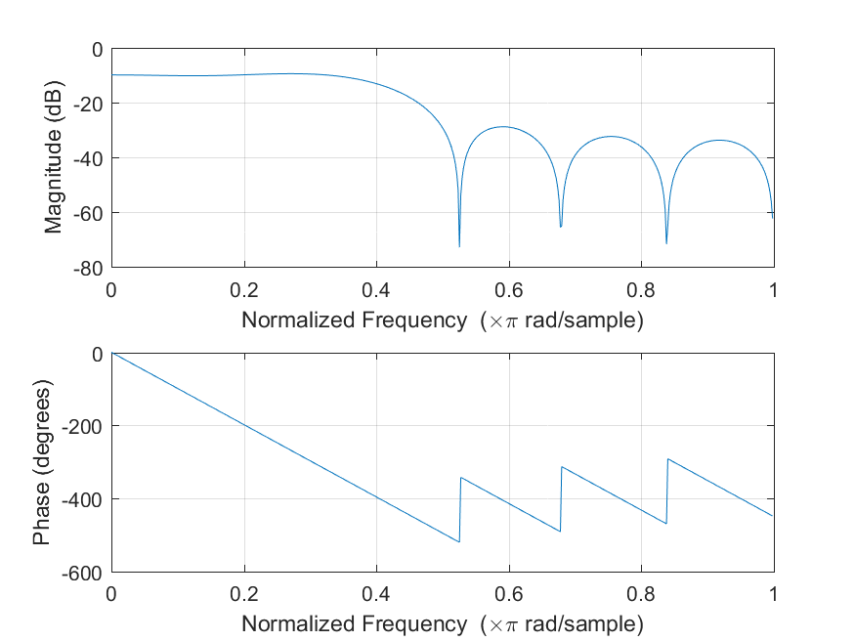

Figure 12: Amplitude and phase plot for N = 11

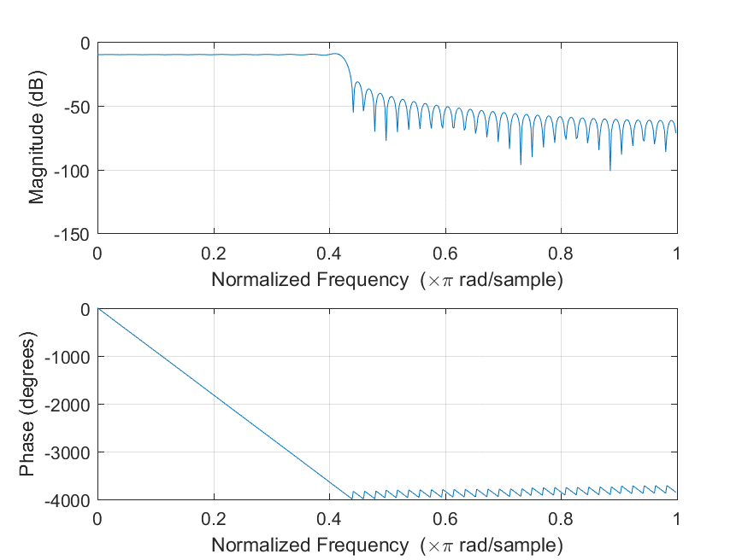

Figure 13: Amplitude and phase plot for N = 101

Explain the influence of N and the behavior of the phase response:

Increasing the length of N, increase the order form of the causal filter ($\tilde{h}[n]$) to a higher order, and since a higher order filter generally does a better job of filtering. It can thus be said that increasing the N increase the filter capability of filter $\tilde{h}[n]$.  
This is especially true for the phase response, this can clearly be seen from figures 11, 12, 13 the higher order N filter is capable of a much better phase filtering.

The fir filter is made up out of zeroes, and poles representing the filter, and every time the frequency passes through the zeroes of the stopband (here the high frequency part of the spectrum), the phase response jump up by pi radians.  
This is the cause of the phase jumps inside the phase response plot.  
The phase angle represents the phase delay of the signal as the frequency increases.   
The different angles for the different N length are needed in order to ensure the desired phase delay for the signal at the cutoff frequency.  
The low pass filter cannot instantly filter a signal, and therefore it needs to have a “build” in in frequency delay in order to behave correctly at the frequency point.

**Assignment 17: Filter design for audio signals 1**

1. Frequency fu:

Using the plot below:

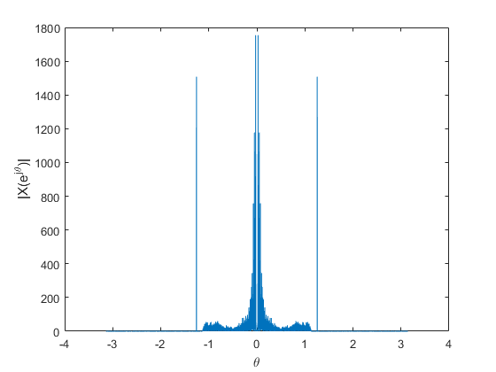

Two major frequency peaks are visible. A pulse at 1.257 and a collection of frequencies that can be identified as noise. In order to filter the noise away, a high pass filter is needed.

$$f_{u}=\frac{1.257f_{s}}{2π}≈8825 Hz$$

1. *{Email your filtered output sound file to* [*t.w.v.d.laar@tue.nl*](mailto:t.w.v.d.laar@tue.nl)*. Please mention your group number in the subject line, and both your names in the email message.}*

